Project Name |  | Confidentiality Level
contract Project |  | For Recipients’ Reference Only
Project ID | Version | Document Code
 |  | Project ID_SD_001

Contract Management System Software System Design Specification



Copyright © Ruankosoft Technologies(Shenzhen), Co., Ltd.
. All Rights Reserved
Revision Record
Date | Revision Version | CR ID /Defect ID | Sec No. | Change Description | Author

Content
1 Introduction 5
1.1 Purpose 5
1.2 Scope 5
1.2.1 Name 5
1.2.2 Functions 5
1.2.3 Applications 5
2 Level 0 Design Description 5
2.1 Software System Context Definition 5
2.2 Design Considerations 5
2.2.1 Design Alternatives 5
2.2.2 Design Constraints 5
2.2.3 Other Design Considerations 6
3 Level 1 Design Description 6
3.1 System Architecture 6
3.1.1 Description of the Architecture 6
3.1.2 Representation of the Business Flow 6
3.2 Decomposition Description 6
3.2.1 Lon in/Register 6
3.2.2 Contract Management 6
3.2.3 Query 6
3.2.4 System Management 6
3.3 Dependency Description 6
4 Data Structure/Database Design 7
5 UI Design 7
Keywords:
Abstract:
List of abbreviations: Describe abbreviations in this document, full spelling of the abbreviation and Chinese explanation should be provided.>
Abbreviations | Full spelling | Chinese explanation
BDMS | Database Management System | 数据库管理系统

- Introduction

Purpose
The file is for others to develop the contract management system. It describes the design of this system.

Scope
    - Name
Contract Management System
    - Functions
Refer to <合同管理系统需求规格说明书>.
    - Applications
It throughout the whole passion which a contract is signed.
- Level 0 Design Description

Software System Context Definition
B/S structure.
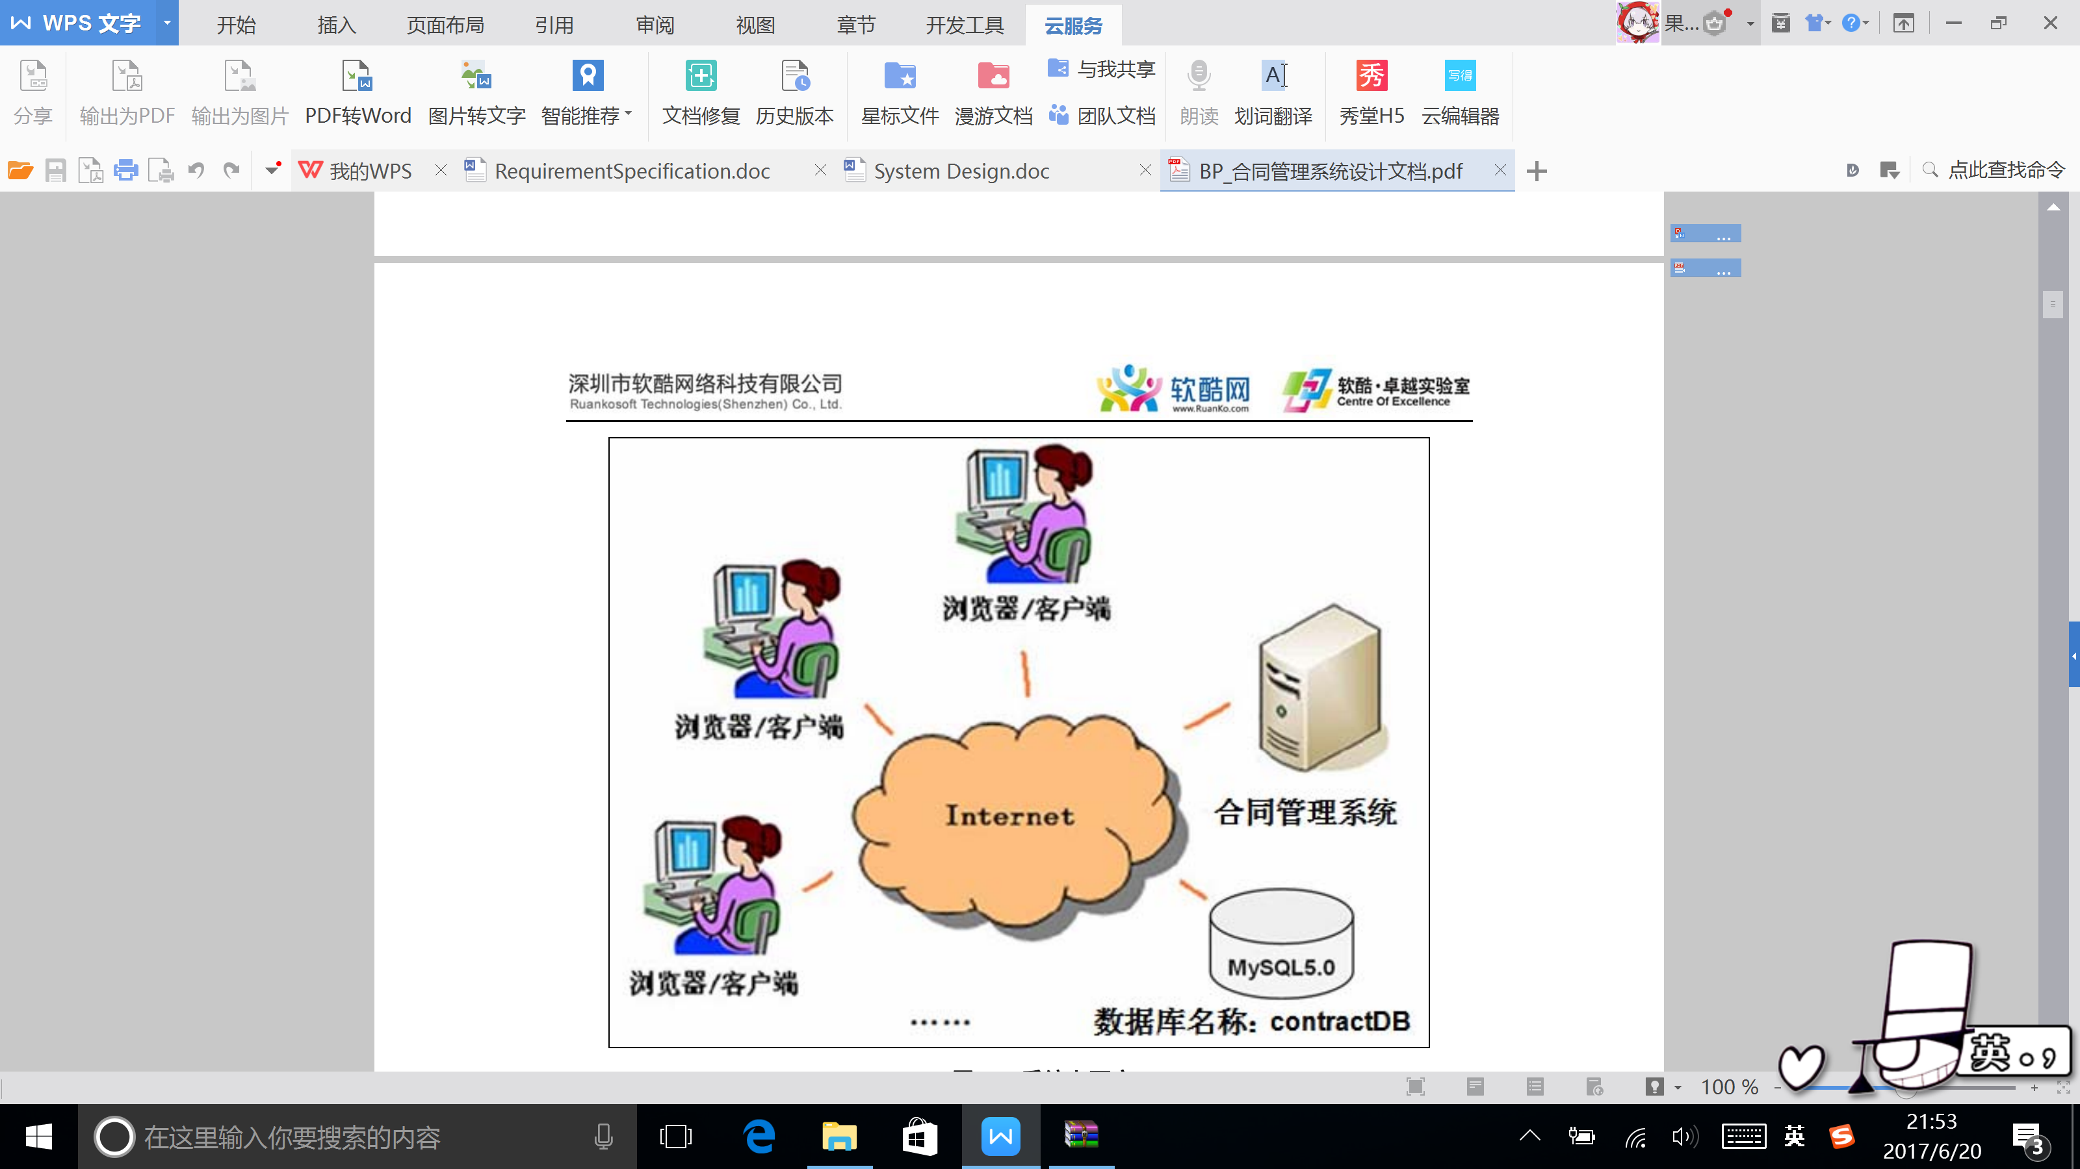

Design Considerations
    - Design Alternatives
Three level structure.
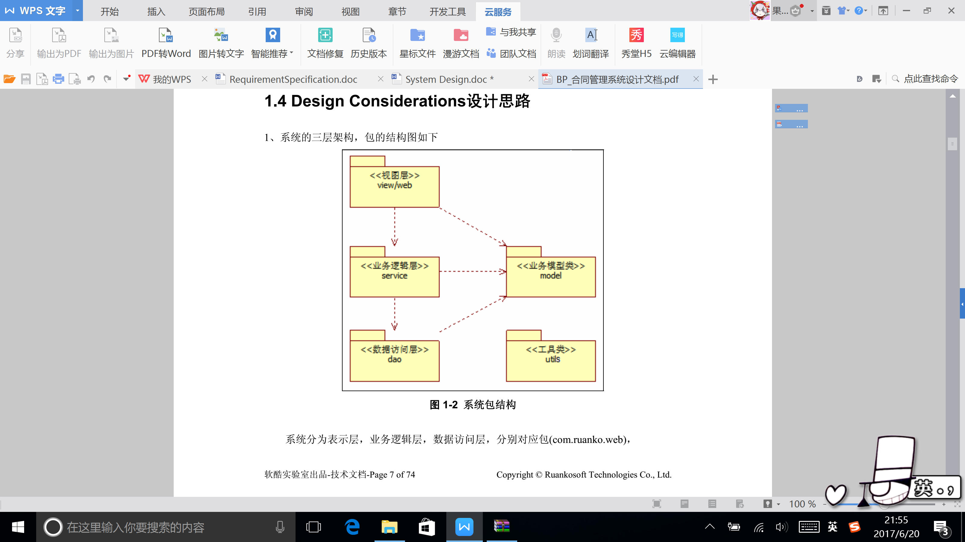
    - Design Constraints
      - Standards compliance
<软酷卓越实验室COE技术要求规范><软酷卓越实验室COE编程规范要求>
      - Hardware Limitations
Low limit: CPU 1GHZ, internal storage 128MB.
      - Technology Limitations
Standard: 软酷卓越实验室COE编码规范
    - Other Design Considerations
Describe other design considerations of the software system.
- Level 1 Design Description

System Architecture
    - Description of the Architecture

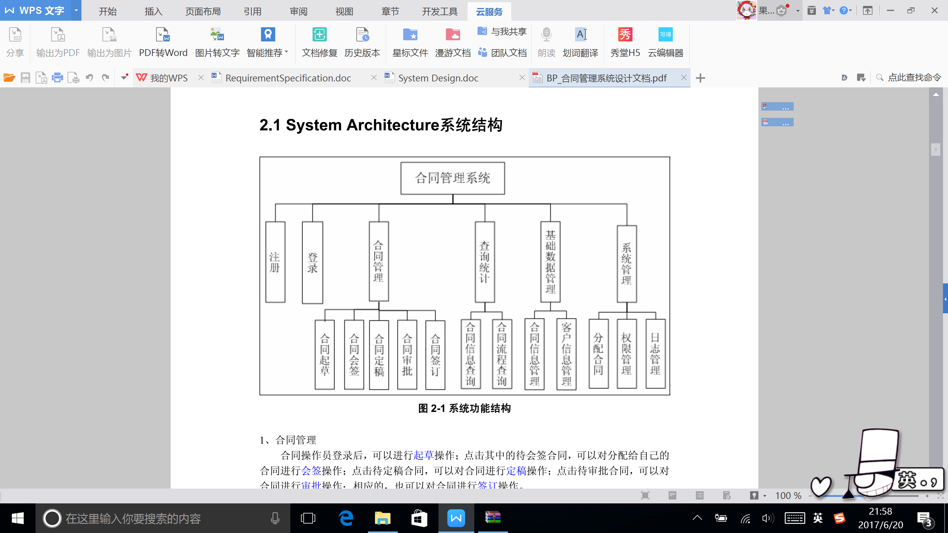
    - Representation of the Business Flow

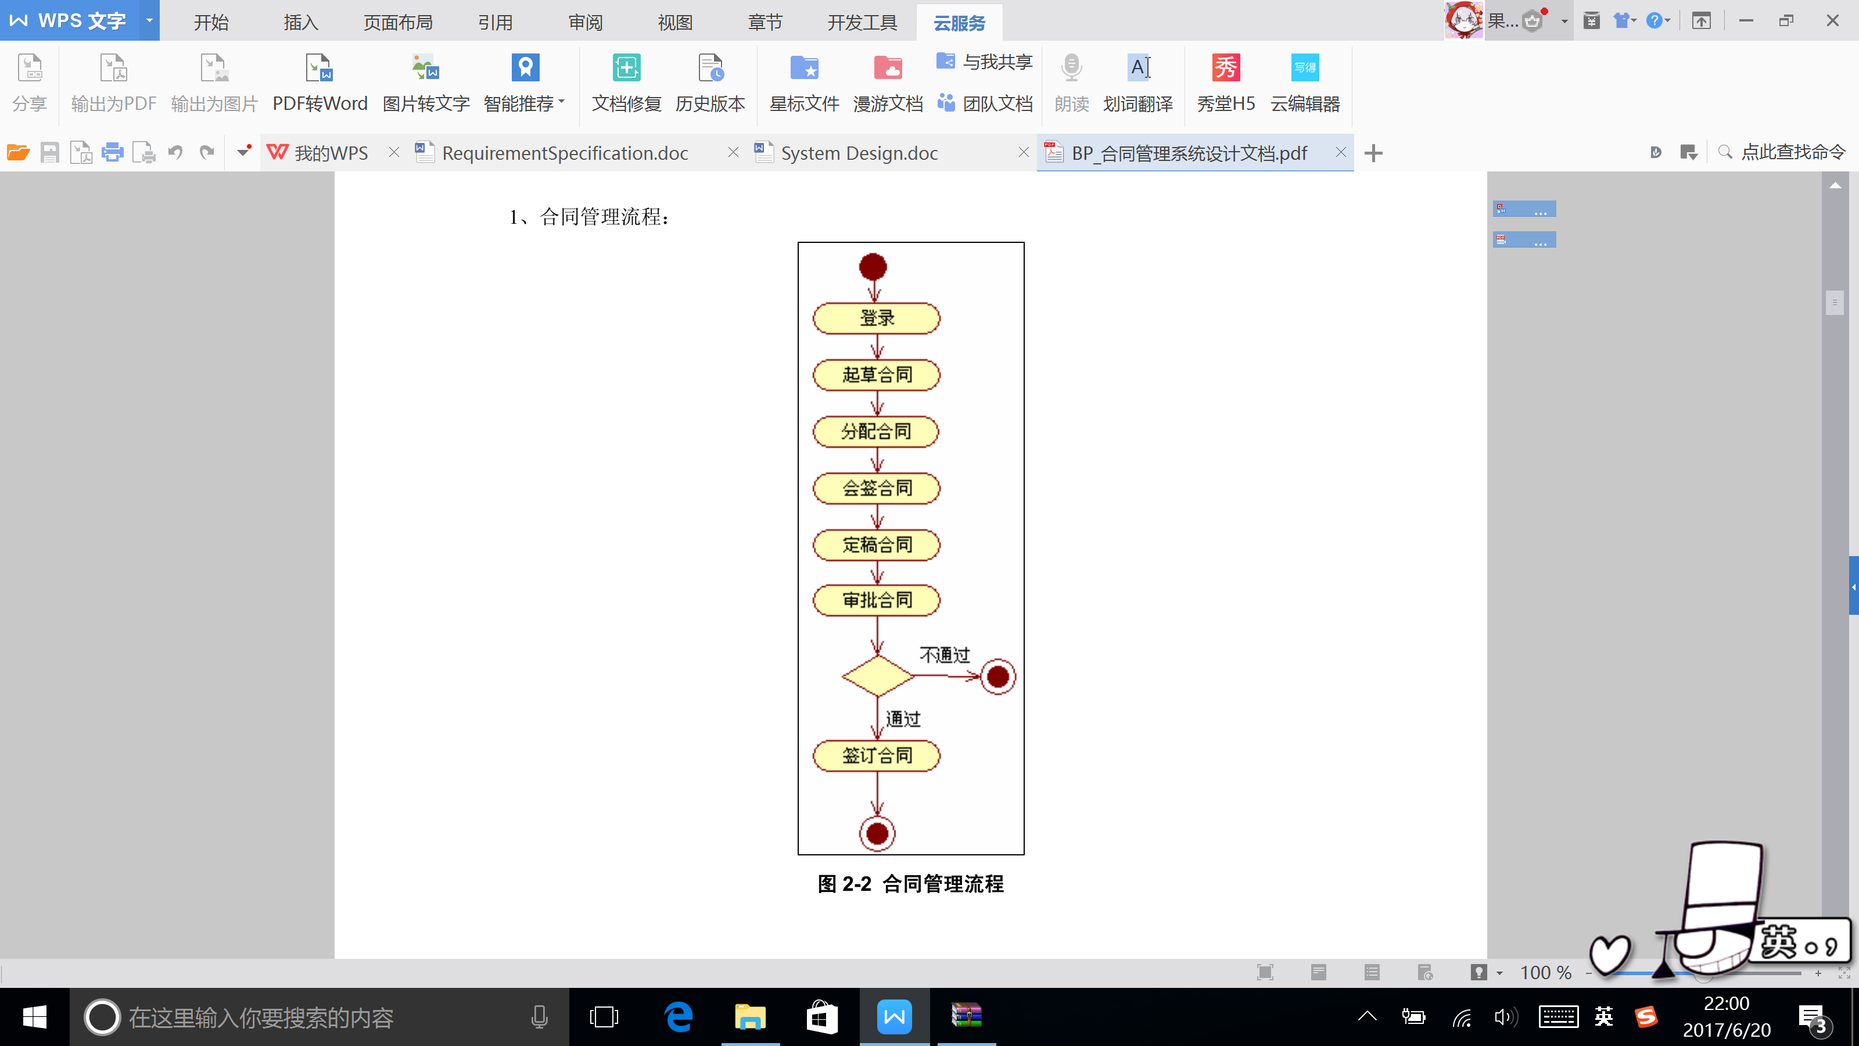

Decomposition Description
This section describes the packages, sub-systems, modules in the system.
    - Log in/Register
- Overview
When you log in, you should input username and password. If you don’t have a registered username, you should register one.

- Functions
Log in: login();
Register: register();
    - Contract Management
- Overview
Draft a contract, Countersign a contract, Finalize a contract, Approve a contract, and Sign a contract.
- Functions
Draft contract: doPost(); draft(); add();
Countersign contract: counterSign();
Finalize contract: finalize();
Approve contract: approve();
Sign contract: sign();
    - Query
- Overview
Query contract information, Query contract process.
- Functions
Query contract information: queryContract();
Query contract process: queryProcess();
    - System Management
1. Overview
Authority.
2. Functions
assignPermission();

Dependency Description
This section describes the relationships among the design entities such as sub-systems, data stores, modules, processes, etc.
Structure charts, transaction diagrams could be used to represent dependences.
- Data Structure/Database Design

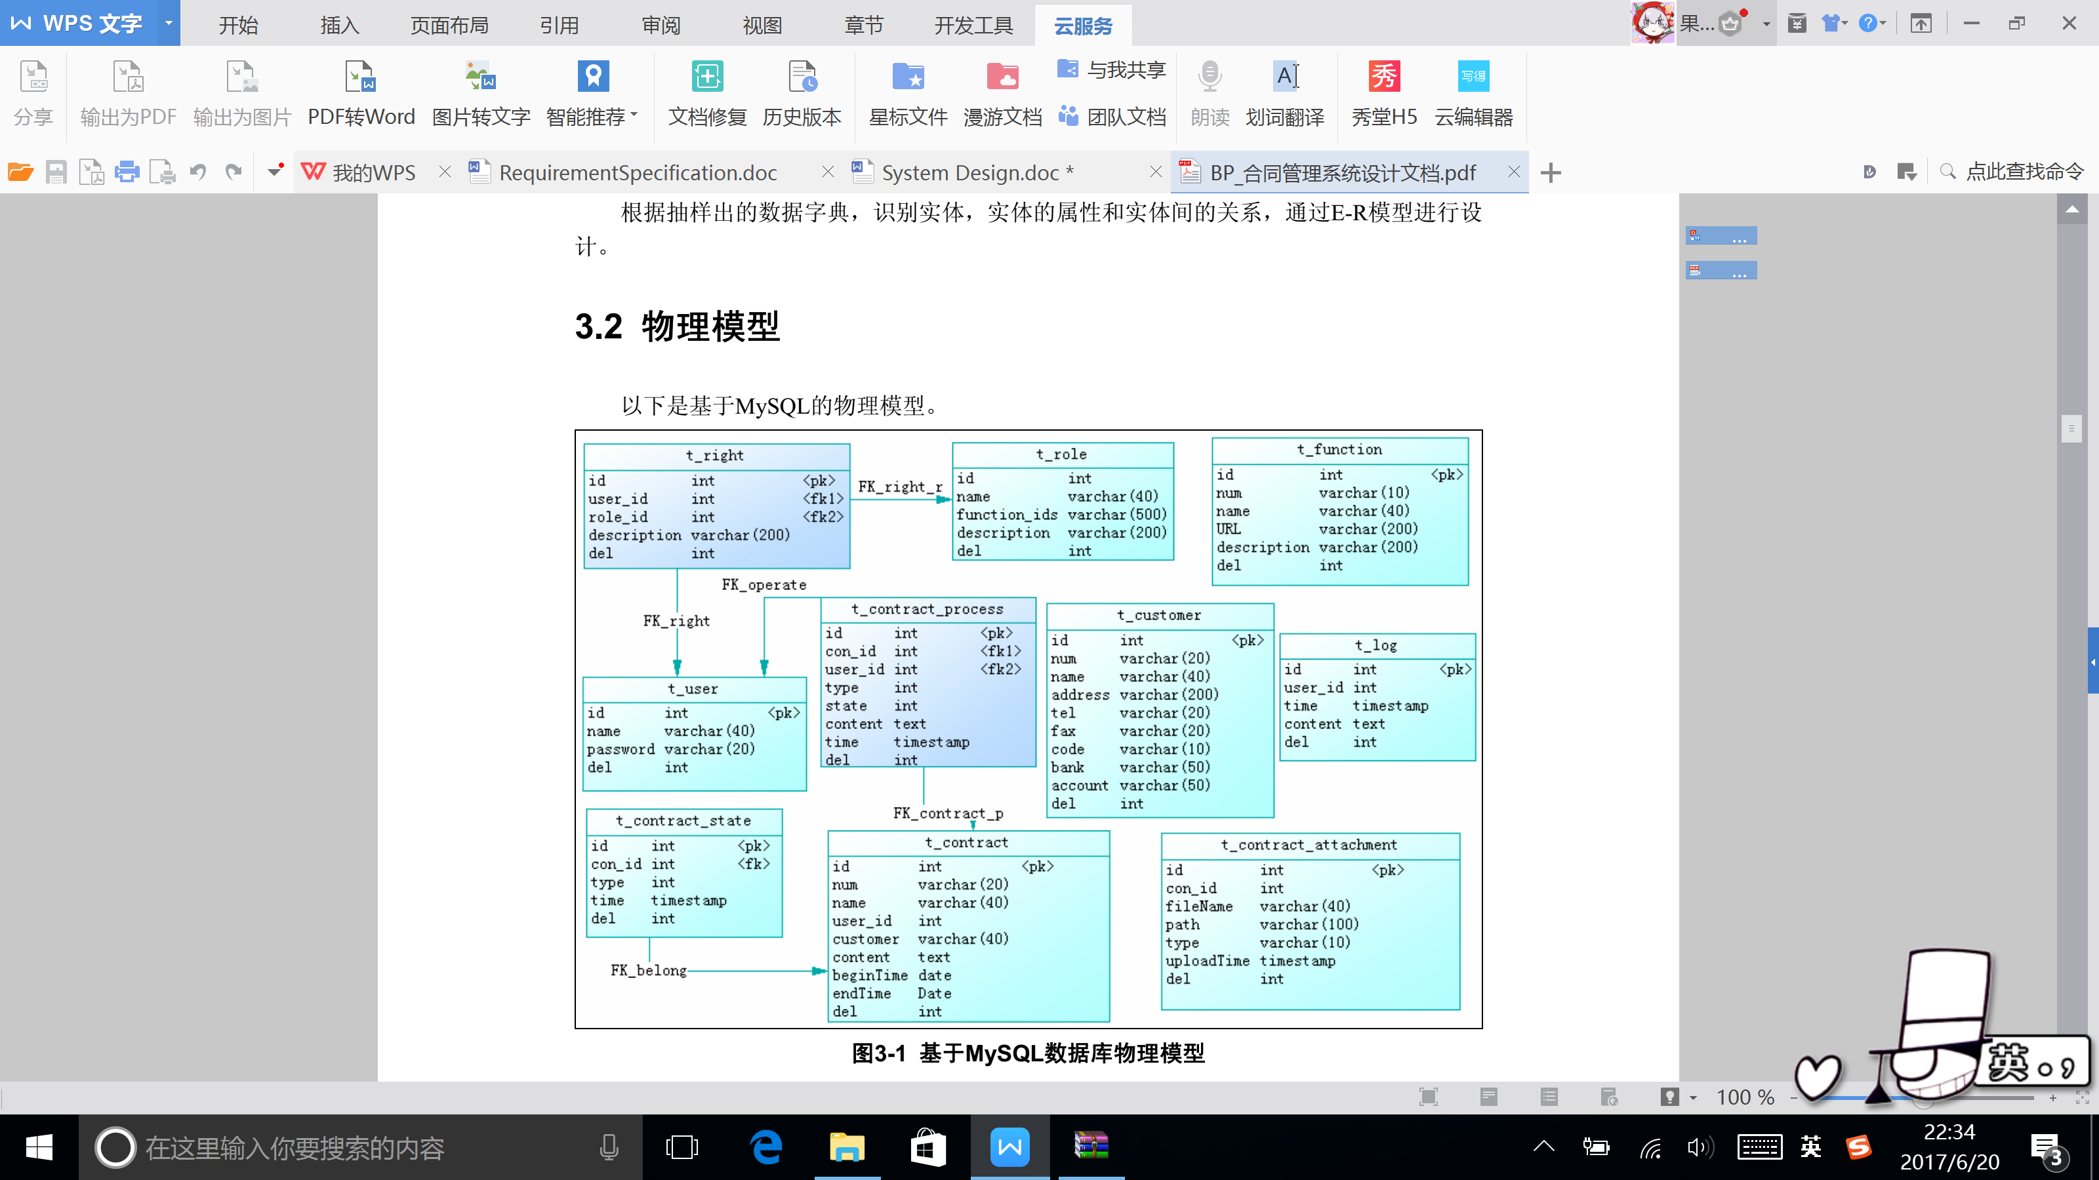
- UI Design
